Charlie Nitschelm

4/8/18

That Belongs in a Museum

The African Burying Ground Reflection

Although I lived in Portsmouth during my entire childhood, I have never visited the African Burying Ground. I must have walked passed it dozens of times, unaware of the history and meaning it brings to Portsmouth. I am hesitant to say that this place is a museum, but more of a memorial. A type of remembrance that is branched from the traditional museum. It did not feel like a museum to me when I visited. I had a cold rush fill through my head as I read the quote from designer. Particularly one line caught my attention: “I stand for those who find dignity in these bones.” It is important to remember the past, and a memorial, which is what I would define this place as, allows me to take in what this town, and many towns like it, were like not long ago. A memorial’s purpose is to educate and make an emotional impact on the visitor. It does not need employees or perfect light. The African Burying Grounds sits in silence among the town, allowing people to experience it individually. It allows people to draw their own conclusions on what it brings forth. For me, I realized how fragile this world is. Reading the main plate filled my body with anger and frustration. I regret how narrow-minded people were, and how we are still fighting many of the same issues that were going on during the era of slavery. This feeling makes me question if humanity will ever achieve world peace. I wonder if humans will ever be able to look at one another and notice how we are alike, not our differences. All hate stems from the priority of noticing how one is different before recognizing how we are the same. Do two eyes, a nose and a mouth not cut it? As we transition into a world where a more physics approach to thinking occurs, we will hopefully begin to move away from our primal instincts to live in a more cosmopolitan world. This burying ground is a step closer for Portsmouth becoming a more cosmopolitan town. It proves that the community can come together for something important and provide it with the justice it deserves. The lives that have been torn and wasted should not go forgotten. This experience was extremely moving, and I appreciate the opportunity to see so much history around me.

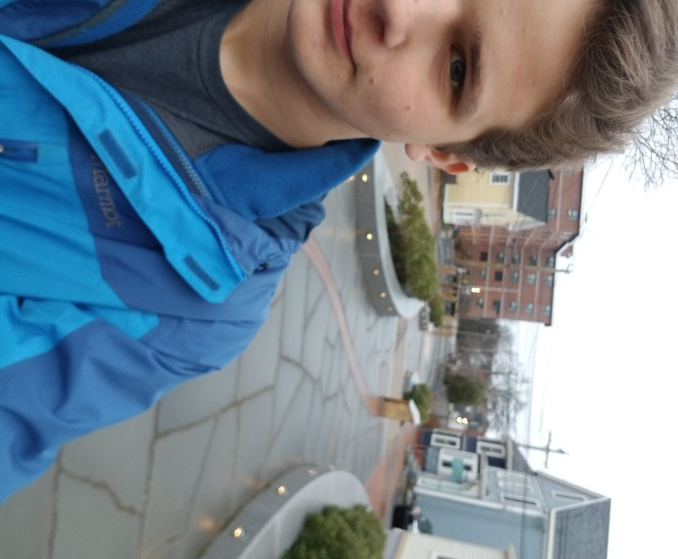

Figure 1- Me at the African Burying Ground in Portsmouth, NH.